Grace UMC Preschool
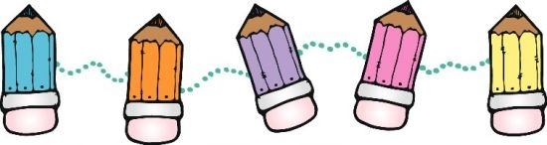
499 N. Country Club, Lake Mary
2020-2021
Grace Preschool is a hands-on, STEAM Christian preschool. Our hours of operation are M-T-W-Th-F, 9 AM- 2 PM. Every child is respected, nurtured, and challenged. Our classrooms are a friendly, safe, and stimulating place where each child can grow spiritually, physically, socially, emotionally, and cognitively. The atmosphere is cheerful and children have many opportunities to explore and discover their expanding world. Children learn that Jesus loves them and so do the teachers! They learn the good news that Jesus made them and wants to be their friend forever.
We recognize the crucial importance of these early years in developing creativity and curiosity. At Grace Preschool each child develops their creativity with a variety of daily art and building opportunities. We promote young children’s natural curiosity and abilities as scientists and engineers by encouraging them to design, invent, play, explore and describe what they see, feel, smell, taste or hear and observe. For example, the children see what will happens when you mix baking soda and vinegar: a chemical reaction!
Each child will need a healthy, age appropriate snack, water bottle and a lunch. NO PEANUT BUTTER. Also, please send in an extra set of clothes. Students must wear closed toed shoes, that are appropriate for outdoor running and climbing. Please send your child in play clothes. Paint that is labled “washable”, is not always washable. Per DCF and our school policies, Grace Preschool is required to have the following documents on file:

________Updated Registration Form
________Childcare Application for Enrollment
________Shot records (Blue Form)
________Physical (yellow Form)
________Flu Form
________Copy of Parent Driver’s License
________Birth Certificate
________Release Form
________Signed Discipline Policy
________Signed Expulsion Policy

Additional documentation for VPK:
________VPK Cetificate of Eligibility
________VPK Attendence Policy

For questions, please call me at 407-322-1472 or email me at graceumcpreschool@gmail.com.

Sincerely,

JoAnne Groce
Director of Grace UMC Preschool

Grace UMC Preschool Price List 2020-2021
Hours M-T-W-Th-F: 2’s/3’s 9 AM-2 PM, VPK 9 AM-12 PM
Tuition | Monthly Fees | Yearly Fees
1 Day | 110.00 | 1045.00
2 Day | 210.00 | 1,995.00
3 Day | 290.00 | 2,755.00
4 Day | 370.00 | 3,715.00
5 Day | 450.00 | 4,275.00
VPK (until 2, monthly) | 140.00 | 1,330.00

- Early Morning Care (subject to availability): 8 AM to 9 AM, $12 per day.
- Late afternoon Care (subject to availability): 2 PM to 3 PM, $12 per day.
- VPK Lunch Bunch 12 PM to 2 PM, $7 per day.
- Daily Drop-in Fee 9 AM to 2 PM, $30 per day
- Any child that is picked up after 2:10 PM will be charged $1200.
Registration and materials fee are non-refundable and due upon registration for two-year-old and three-year-old class. Siblings will get a 10% discount. There are no mandatory fees for VPK classes. It is our policy to request a one-time donation of $110 to help cover the cost of special crafts, activities and events for VPK students.
Registration fee per family: $75.00
Materials Fee: 1 day a week $75
2 days a week $110
3, 4 or 5 days a week $140

Child’s Name____________________________________________D.O.B.___________
____My child is two by September 1, 2020
____My child is three by September 1, 2020
____My child is four by September 1, 2020
I am interested in the following days: ___ M ____T ____W ____Th ____F
I am interested in the VPK Lunch Bunch: ___ M ____T ____W ____Th ____F

Parent’s Signature ___________________________________Date____________

Updated 2-10-20, JG

Grace UMC Preschool Release Form

Medical Release: In the event that my son/daughter should need medical treament by the school personnel or any Emergency Medical personnel, my signature below will authorize Grace UMC Preschool to provide or secure such treatment without delay. In the event of a serious accident or illness I will be notified as quickly as possible.

Parent’s/Gaurdian’s Signature___________________________________Date______________

Picture Release: From time to time, Grace UMC and Grace Preschool will be taking pictures of your child to document activities at school or church. Some of these may be used for publicity or promotion. They also may be posted on Facebook or the church website.

I grant permision for Grace UMC or Grace UMC Preschool to take pictures of my child for school, church or promotional purposes. ______Yes _____No

Parent’s/Gaurdian’s Signature___________________________________Date______________

Permission to Assess: By signing below I give my permission to assess my child. I also give permission for the results to be shared with my child’s subsequent teacher or school, should it be requested.

Parent’s/Gaurdian’s Signature___________________________________Date______________

Food Policy: By signing below I allow my child to participate in special event where food is provided. This includes both store bought sealed items and homemade. I understand my child’s allegies will be posted in their classroom.

Parent’s/Gaurdian’s Signature___________________________________Date______________

On-Site Field Trips: By signing below I am allowing my child to participate in on-site field trips. These include Chapel in the sanctuary, walking around on the church grounds, and visiting other rooms in the church such as the kitchen, fellowship hall, sanctuary, or office.

Parent’s/Gaurdian’s Signature___________________________________Date______________

Immunizations: By signing below I am acknowledging that there may be a child on premises who’s immunizations have expired or who may not be immunized due to religious exemption.

Parent’s/Gaurdian’s Signature___________________________________Date_____________

Updated 2-10-20, JG

Discipline Policy for Grace UMC Preschool
Redirection: We believe that children should always have an opportunity to make safe, healthy choices. “Discipline” means to teach, not punish. Teachers will redirect a child's attention, offering a different age-appropriate activity than the activity with which they are struggling or having trouble cooperating with peers. Children like to make the right choices, and this encourages them to keep on trying.
Prevention: Our approach focuses a great deal on prevention. When dealing with young children, preventing behavior is always easier than trying to deal with it after the fact. One way we encourage positive behavior is to provide several of each toy. Also, we have a low teacher student ratio, so teachers have time to play and interact with each child during the day.
Positive Philosophy: We use a positive philosophy that helps children understand what they can do as opposed to what they can't do. For example, we say “walking feet” instead of “no running”. Children's emotions will be acknowledged, and teachers will show empathy as children experience the ups and downs of a typical day. A caring and positive approach will be taken regarding behavior management and discipline. The teachers will focus on the positive behaviors of the children and reinforce those behaviors as often as possible. Our goal is to help the children develop self-control and responsibility for their actions.
Communication Policies
Parents will be notified immediately in case of major or reoccurring behavioral challenges. Teachers will provide a detailed account of any incidents and parents will be required to sign the incident report, indicating that they have read and understand what happened. The director will meet with parents to discuss a plan of action, to meet that child’s needs.

I have read and understand the discipline policy at Grace UMC Preschool. I have been given a copy for my own records.

Parent’s/Guardian’s Signature________________________________________ Date_________

Updated 2-10-2020 JG

PARENTS’ COPY

Discipline Policy for Grace UMC Preschool
Redirection: We believe that children should always have an opportunity to make safe, healthy choices. “Discipline” means to teach, not punish. Teachers will redirect a child's attention, offering a different age-appropriate activity than the activity with which they are struggling or having trouble cooperating with peers. Children like to make the right choices, and this encourages them to keep on trying.
Prevention: Our approach focuses a great deal on prevention. When dealing with young children, preventing behavior is always easier than trying to deal with it after the fact. One way we encourage positive behavior is to provide several of each toy. Also, we have a very low teacher student ratio, so teachers have time to play and interact with each child during the day.
Positive Philosophy: We use a positive philosophy that helps children understand what they can do as opposed to what they can't do. For example, we say “walking feet” instead of “no running”. Children's emotions will be acknowledged, and teachers will show empathy as children experience the ups and downs of a typical day. A caring and positive approach will be taken regarding behavior management and discipline. The teachers will focus on the positive behaviors of the children and reinforce those behaviors as often as possible. Our goal is to help the children develop self-control and responsibility for their actions.
Communication Policies
Parents will be notified immediately in case of major or reoccurring behavioral challenges. Teachers will provide a detailed account of any incidents and parents will be required to sign the incident report, indicating that they have read and understand what happened. The director will meet with parents to discuss a plan of action, to meet that child’s needs.

I have read and understand the discipline policy at Grace UMC Preschool. I have been given a copy for my own records.

Parent’s/Guardian’s Signature________________________________________ Date_________

Updated 2-10-2020 JG

GRACE UMC PRESCHOOL EXPULSION POLICY
Unfortunately, there are sometimes reasons we have to expel a child from our program either on a short term or permanent basis. We want you to know that we will do everything possible to work with the family of the child(ren) in order to prevent this policy from being enforced. The following are reasons we may have to expel or suspend a child from this center:

IMMEDIATE CAUSES FOR EXPULSION
- The child is at risk of causing serious injury to other children or him/herself.
- Parent threatens physical or intimidating actions towards staff members.
- Parents exhibits verbal abuse to staff in front of enrolled children.

PARENTAL ACTIONS FOR CHILD’S EXPULSION
- Verbal (including online) or physical abuse to staff.
- Failure to pay/habitual lateness in payments.
- Failure to complete required forms including the child’s immunization/health records.
- Habitual tardiness when picking up your child.

CHILD’S ACTIONS FOR EXPULSION
- Failure of child to adjust after a reasonable amount of time.
- Uncontrollable tantrums/angry outbursts.
- Ongoing physical or verbal abuse to staff or other children.
- Excessive biting.

Prior to expulsion, a parent will be called and correspondence will be sent home indicating what the problem is, and every effort will be made by both the center and the parent to correct the problem. If, after one or two weeks, depending on the risk to other children’s welfare or safety, behavior does not improve, and the center finds that they can no longer accommodate the child, the parent will be asked to remove him/her.

By signing below, I acknowledge that I have received the Grace UMC Preschool Expulsion Policy.

Child’s Name :_____________________________________________

Signature:__________________________________________________ Date_____________

Updated 2-10-2020 JG

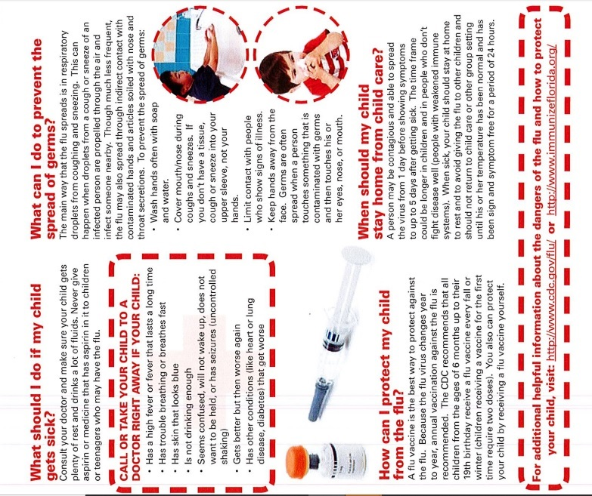
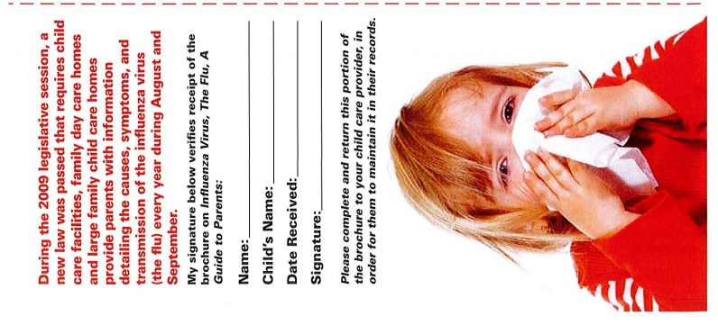

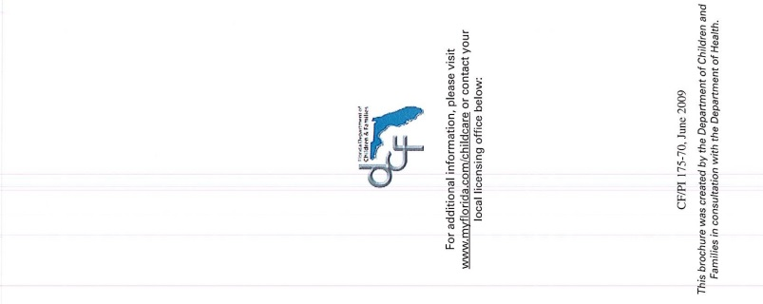
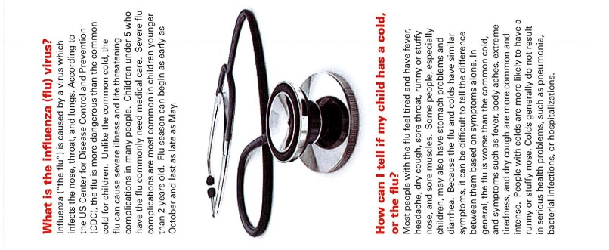

VPK ATTENDANCE POLICY 2020-2021

Welcome to Grace UMC Preschool VPK Program! Our goal is to provide a high-quality prekindergarten learning experience that will prepare your child to be successful in kindergarten. To obtain this goal, we recognize that regular daily attendance is vitally important to your child’s kindergarten readiness. Our attendance policy was adopted following Florida’s Voluntary Prekindergarten Program’s attendance requirements.

By initialing each item, you are verifying that you understand and will comply with each requirement.

VPK Attendance Requirements:

___VPK Start date is 8/10/20.

___VPK end date is 5/25/21.

___VPK hours are 9 AM to 12 PM . It is important that parents adhere to the start time. Late arrivals are disruptive to the group and awkward for the arriving child.
.
___ Absences cannot exceed more than 20% of the instructional days each month. This means the child can only miss 3 days out of each month. The 20% does not apply to scheduled holidays or other school closings. Please refer to our school calendar for holiday closures and plan your vacations in accordance with these dates.

___A child with excessive absences (more than 20% each month) may jeopardize his/her
continued enrollment in the VPK program.

___Parents are required to sign a monthly child attendance certificate verifying their
child’s daily attendance in the program.
.

I have read, understand, and agree to the above polices.

________________________________________________________________________________
Parent/Guardian Signature DATE

Child’s Name:_____________________________________________________________________

Updated 2-10-2020 JG

